Springmead Newsletter

No. 6 ~ 2022/23

Thursday 13th October 2022

Dear Parents,

The children have had a rich experience over the last six weeks and have worked incredibly hard. I would like to thank everyone, children and adults alike, for your support and commitment and wish you all a good holiday. We look forward to seeing you at the church tomorrow afternoon, Harvest Festival is always a moment to remember just how much we have to be grateful for and is a lovely send off at the end of a busy half term.

PLEASE do keep up reading over the holiday and Showcase performers keep polishing your acts!

Thank you everyone for your generous donations this morning, the car was full to the brim!

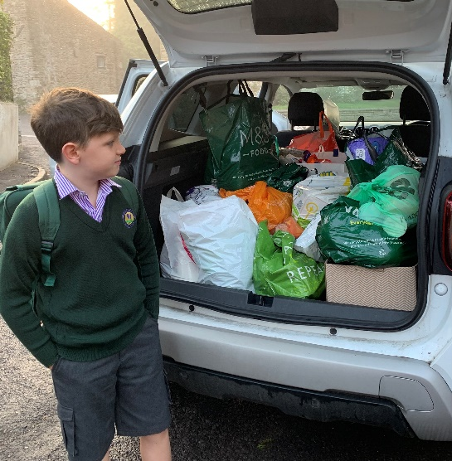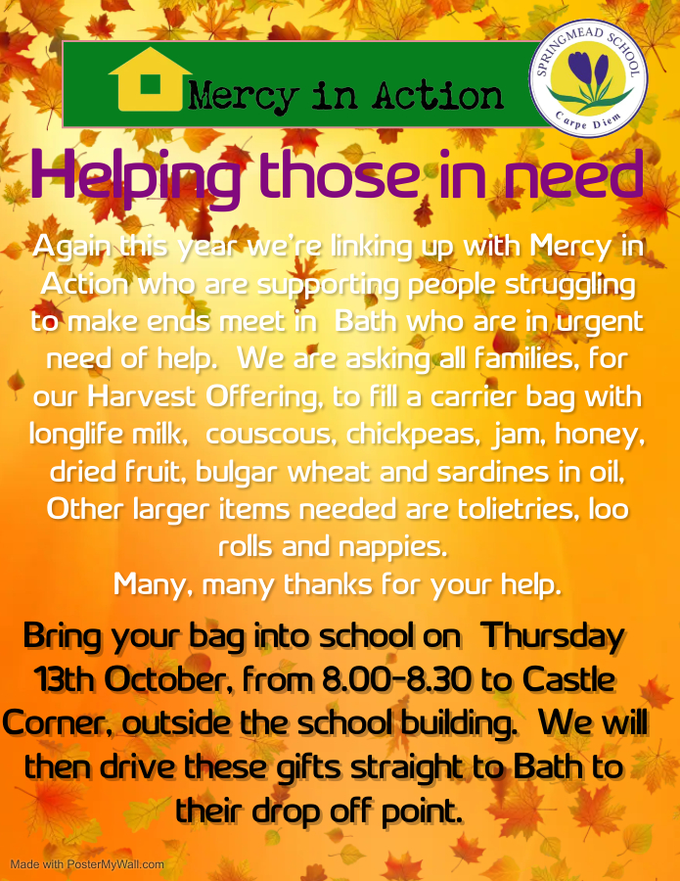

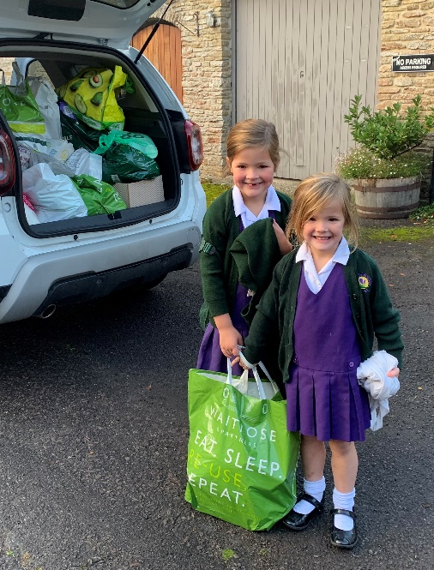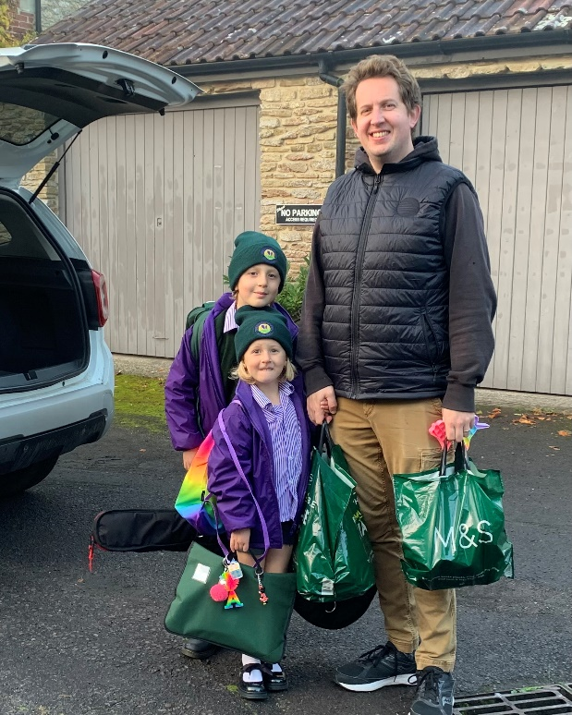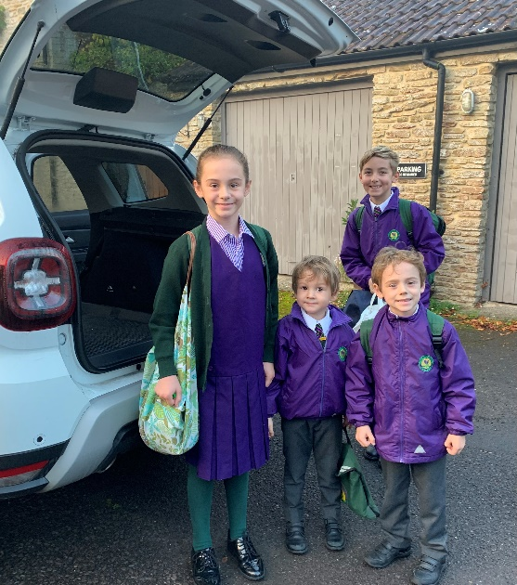

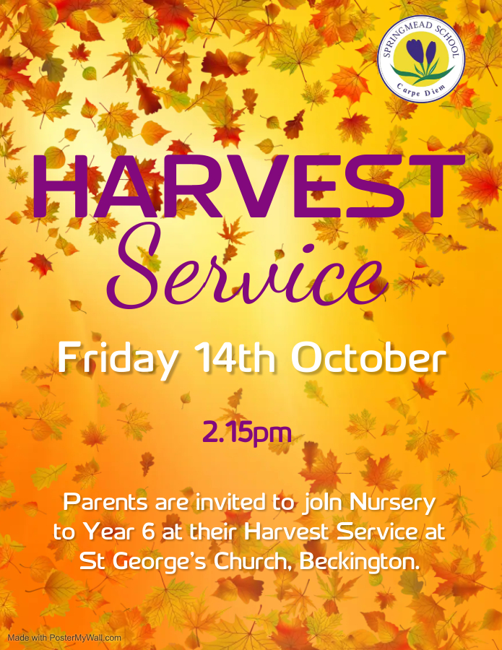

**Reminder for tomorrow:**

As usual this year we are holding our Harvest Service during the school day. This year the date for your diary is Friday 14th October at 2.15 pm, at St George’s Church. The service will last approximately 45 minutes and afterwards children will be free to go home with their parents. Clubs will carry on as usual for those who want to attend. Children should not bring in school bags that day. Due to the lack of parking near the church on Church Hill and Church Street, please park in the usual area on the Frome Road and walk to the church. You may need to allow extra time to do this! **Out of consideration for our young performers,** we would ask adults bringing toddlers and babies to stay at the back of the church in order to be able to take them outside very promptly should they become restless during the service.

|  |
| --- |
| **The Importance of attendance as we go into next half term**  Over the last few months there have been many studies undertaken to assess the impact of reduced attendance on children’s learning.  As noted in the DFE Guidance – ‘Working Together to Improve School Attendance’ May 2022  **‘The pupils with the highest attainment at the end of Key Stage 2 and Key Stage 4 have higher rates of attendance over the key stages compared to those with the lowest attainment.’**  **Children will always have illnesses that cannot be avoided. However, we should all be ambitious for high school attendance, our expectations are high; mild ailments should not result in a missed day, appointments should, wherever possible, be made outside of the school day and holidays should be outside of term times, in this way we are giving our children the greatest opportunity to do well.** |

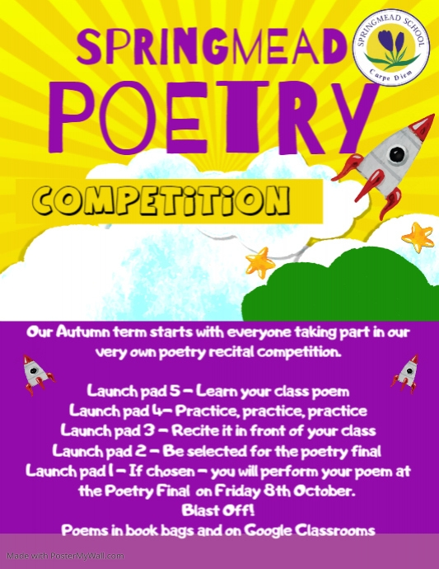

|  |
| --- |
| **Springmead Poetry Performance Competition 2022: Final**  Well done to this year’s winners:  **Reception- Ada Ruggiero- Jansch**  **Year 1- Arthur Belcher**  **Year 2- Darcey Jamieson**  **Year 3- Florence Morgan**  **Year 4- Scarlett Baker**  **Year 5- Asher Belcher**  **Year 6- Skye Hillman**  **The House awarded the poetry cup this year was Spring for accruing the most house points over the whole competition.**  Over the last few weeks, nearly every child in the main school has learnt and recited a poem in front of their class; this week we enjoyed the final at the Village Hall, what a lovely event! This week’s final was a competition, sometimes in life we face competitions, learning to win and lose are equally important. As parents and educators, we need to give our children the opportunities to feel and experience both. In the famous words of Winston Churchill, ‘Success is not final, failure is not fatal: it is the courage to continue that counts.’ It is for these very reasons that school’s balance the need for competition alongside non-competitive events. |

|  |
| --- |
| **Personnel Change**  As the half term draws to a close we prepare to say farewell to Maria Keates as she heads off on maternity leave. Thank you for your support Maria and we look forward to hearing good news in due course!  We are looking forward to announcing our new teaching assistant when arrangements are confirmed. |

|  |  |  |  |  |  |  |  |  |  |  |  |
| --- | --- | --- | --- | --- | --- | --- | --- | --- | --- | --- | --- |
|  |  |  |  |  |  |  |  |  |  |  |  |

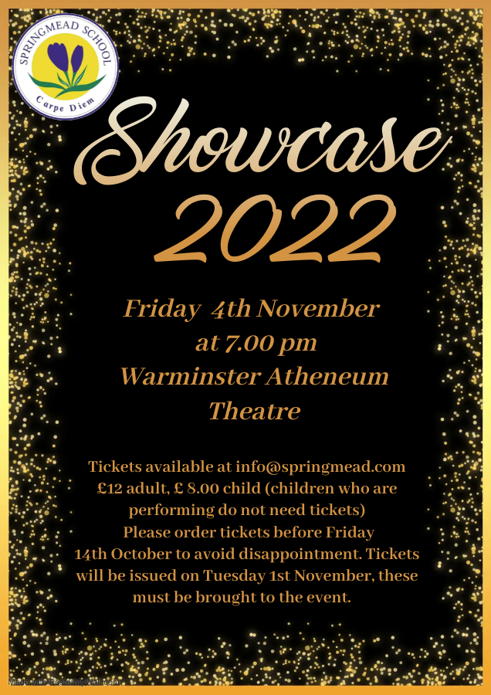

To enhance the experience of the children this year, wherever possible children will be sitting watching the show from the first few rows of the auditorium for at least some of the show

(unless there are costume and microphone issues requiring them to be back stage for a few children who appear in different acts). Please note you do not need to request tickets for children who are performing.

**PLEASE HAVE ORDERS IN BY TOMORROW, FRIDAY 14th OCTOBER**

**IMPORTANT INFORMATION**

**FOR WEDNESDAY 2nd NOVEMBER**

**Reminder: Wednesday 2nd November, Showcase Rehearsal**

Showcase technical rehearsal will take place at the Athenaeum Theatre in Warminster. Please note that all props, instruments, and costumes will be required for the rehearsal: props will stay at the theatre ready for Friday.

**Wednesday 5th November, Poetry Enrichment Day**

This day will be a busy one, in classroom time the children will be immersed in poetry and creative writing activities and those involved in Showcase will be transported to the theatre and back to rehearse.

**To accommodate the different timings this day all children will be having picnic lunch.**

**If you have any queries at all please email Charlotte Munckton on cmunckton@springmead.com**

|  |
| --- |
| **Reminder of the Showcase line up (not running order)**  **Ensembles**   * Pre- Prep Choir * Prep Choir * Choral Group and staff choir * Musical Theatre * Year 4 dance * Poetry performance winners * Music Ensemble * Yr 6 presenters – Harry Fraser, Ruben Percival Caddis, Panashe Tondoro, Felix Young, Felix Millard, Skye Hillman, Ava Pellow, Oliver Keirle * The Drury Family   **Yr2**   * Darcey Jamieson – Solo * Hannah Tondoro, Charlotte Morrell, Beau Baker, Maddie Ryan, Hebe Hughes Potashnick, Holly Davis- Gym Squad * Lizzie Cochrane – composed own poem   **Yr3**   * Polly Newmarch – Solo * Martha Rider -  Piano * Everly Ballinger and Owen Ruggiero Jansch  – Duet * Owen Ruggiero Jansch  – Solo and guitar   **Yr4**   * Mabel Munckton and Rose Wilson – Tap * Mabel Munckton – Solo * Katerina Lazaridou – Solo * Ava Curran – Taekwondo   **Yr5**   * Poppy Newman - Solo * Lily Hurst – Gymnastics   **Yr 6**   * Sienna Marshall – Cello * Sienna Marshall – Drama * Immy Bagan – Solo * Sam Ricks and Phoebe Fisher – Duet * Bella Bush - Drama   **Alumni student**   * Maria Lazaridou  - solo |

**PLEASE NOTE THE CHANGE OF DATE**

**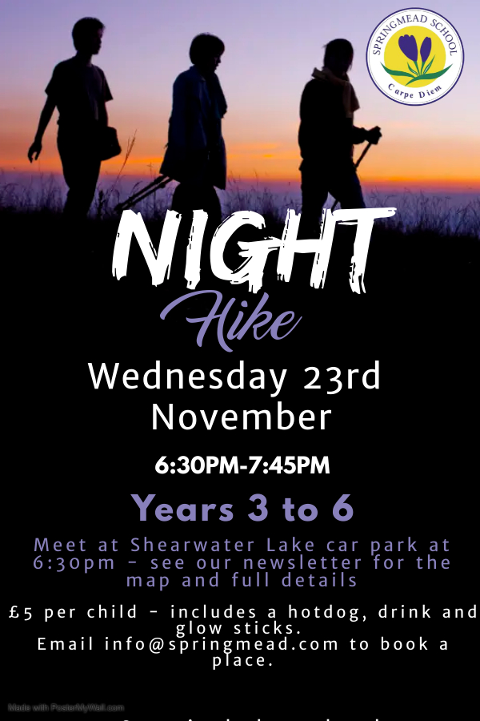**

**For those new to the school, this is an exciting event for our older children in Years 3-6 where we walk through the forest at Longleat, in the dark with glow sticks, torches and much excitement.**

Important Information for Parents

* This event is for Springmead pupils in Year 3 and above only
* Please drop off your child at Shearwater car park (see map attached) for a prompt 6.30pm start; the walk will finish at approx. 7.45pm at Shearwater
* At the end of the walk hotdogs and drinks will be provided for the children
* The walk will be supervised by school staff
* Children should wear warm clothes with a waterproof jacket and suitable footwear (walking boots, wellies or trainers)
* The walk will go ahead, whatever the weather, unless conditions are dangerous
* Children can bring a small torch.

|  |
| --- |
| **Performing Arts**  It's been a truly reflective week in the music department this week... as Harvest approaches, we've taken time, through studying lyrics, to consider how lucky we are to have the opportunities we have, the food we eat, the school we attend, and much more. We have also been thinking about those who don't share our opportunities, those who struggle to feed their families, and those who don't get the chance to thrive in such an exciting and inclusive environment as ours.  When we rehearsed our Harvest Service in the church on Tuesday, we realised that our current Year 3 children last performed in a live Harvest Service when they were in Reception. The dreaded Covid stopped most live performances since 2019, we are so excited to be back and able to share our hard work with you, offering our talents and seizing those opportunities to be our best selves. We look forward to seeing you at the Church for the service tomorrow, and know that you will be delighted by the volume of excellence among our community of children!  **Hannah Drury** |

**Christmas Gift Shop**

The children at Springmead have relished the experience of going to the Christmas Gift Shop and buying presents for members of their family over many years. Going into a shop and just thinking about gifts for others, rather than for yourself, is a very big thing and ties in so wonderfully with the whole Christmas message of giving. Our gift shop is a valuable event that relies entirely on the generous donations from parents and staff.

This year the Gift Shop will work as follows:

* The shop will be open on Wednesday 8th December for children to select presents for their family
* The children and their teachers will gift wrap and label the items.
* All presents cost £2.00, children are allowed to spend a maximum of £10.00, on up to 5 presents.
* Children will be asked to bring in their shopping money in an envelope marked with their name and the names of the family members for whom they are buying gifts, the week before the shop opens. This will help us to ensure we have enough gifts of the right sort!
* Gifts can come into school in carrier bags from now onwards
* Money raised from the Gift Shop will be used to buy additional equipment for the children, through the Springmead School Association committee.

**The shop relies completely on donations from parents, gifts should be something your family members would like to receive, such as toiletries, stationery or toys.**

|  |
| --- |
| **C:\Users\mtaylor.SPRINGMEAD\AppData\Local\Microsoft\Windows\INetCache\Content.Outlook\3N3B5S4O\Image (011).jpegSports News**  **Year 5 hockey**  After a quick warm up and team discussion about positions the Year 5 were off! The girl's enthusiasm was infectious, and you couldn’t ask for them to try any harder. Unfortunately, on the day, Warminster were the better team. 2 fantastic goals from Iris and Bea didn’t match Warminster’s goals. Great effort girls.  **C:\Users\mtaylor.SPRINGMEAD\AppData\Local\Microsoft\Windows\INetCache\Content.Outlook\3N3B5S4O\Image (013).jpegYear 6 Hockey**  The year 6 girls came well prepared from the previous fixture at Stonar school. They knew confidently what positions they wanted to play and went in with a positive mindset that they were going to win! The girls worked well as a team, lots of communication and spacing which enabled them to score 3 fantastic goals.. Well done girls. Final score Warminster 2 - Springmead 3!!!  C:\Users\mtaylor.SPRINGMEAD\AppData\Local\Microsoft\Windows\INetCache\Content.Outlook\3N3B5S4O\Image (015).jpeg  **Reception PE**  The children in reception are always raring to go in PE lessons. Last week we focused on climbing and jumping using our gymnastics equipment. We looked at how to transfer our weight in our body when climbing up and down the climbing frame. We also practised landing safely when jumping off benches and the vault!  I am so impressed by their ability to change into their PE uniforms with minimal help. Well done, Hedgehogs!    **Year 1 and 2 PE**  Year 1 and 2 have just finished their unit on ‘kicking’. We practised a variety of different skills and techniques. Last lesson we began to learn about attacking and defending and space. This is a new skill for a lot of children, some children understanding how to attack and not how to defend and making sure we don’t all crowd for the same ball. Well done Year 1 and 2 – excellent effort in PE lessons this half term.  **Upcoming fixtures and events…** Monday 7th November – Year 3/4 Hockey vs Beckington (home – selected children) Tuesday 1st November – Year 3-6 sports hall athletics @ Frome sports centre Tuesday 8th November – Year 3-6 Cross Country Monday 14th November – Year 3/4 girls Hockey vs Warminster (all girls) Monday 21st November – Year 3/4 boy football vs Warminster (home – all boys) Monday 28th November – Year 3/4 girls hockey vs Stonar (all girls) Wednesday 30th November – Year 5/6 boy Football @ Warminster (all boys)  If you have any queries about PE that can directed to the PE staff rather than your child’s class teacher, or need information about fixtures, please use our direct email address, as follows: [pedepartment@springmead.com](mailto:pedepartment@springmead.com)  **Emma Lindley**  **Swimming**  We hope that everyone will get to go some swimming over the half term break to continue the great work on skills, confidence and technique we have been working on in the pool. There are often week long intensive courses available to really hone your skills and make quick improvements. There might be a pool at holiday venues for those lucky enough to be going away this break. Or perhaps you could enjoy a family swim together and your child can show off all the skills they been practising. Any additional time in the pool will be beneficial!  **Super swimmer of the week**: Arlo Hinder for showing brilliant confidence in the water.  If you would like to speak to a member of the swimming team, please feel free to call me, Sarah Cozens, at school between 9:00am and 10:00am every Thursday, alternatively you can email me at scozens@springmead.com. Please note I usually only pick up these emails on Thursdays. For pastoral issues related to swimming, please speak to the class teacher as they are around much more during the week.  **Sarah Cozens** |

|  |  |
| --- | --- |
| **Praise Certificates**  The following children received praise certificates this week | |
| **DUCKLINGS**  **(YN)** | Esraa Syed – for always being the first to help with tidying up.  Edith English Dedieu – for great imagination with small world play. |
| **HEDGEHOGS**  **(YR)** | Barnaby Newmarch – fantastic progress with his writing skills.  Cora Drury – super progress with her reading- excellent blending skills. |
| **RABBITS**  **(Y1)** | Mathilde English Dedieu ­– amazing maths.  Freya Gripper –amazing maths.  Esther Foster-Jones – amazing maths. |
| **OTTERS**  **(Y2)** | Charlotte Morrell – for a fantastic drawing of The Houses of Parliament.  Lizzie Cochrane – for a great retelling of The Gunpowder Plot.  Maddison Ryan – for working so hard in phonic lessons. |
| **BADGERS**  **(Y3)** | Jack Tucker – for throwing yourself into all of your work with enthusiasm and vigour.  Annabel Pereira – for doing your best to be your best self.  Owen Ruggiero – Jansch – for good interrogation of the Police. |
| **SQUIRRELS**  **(Y4)** | Rose Wilson – for a clear and thoughtful plan in DT.  Reece Oliver – for great work comparing the ancient and modern Olympic Games.  Scarlett Baker – for always being so enthusiatic and sharing her knowledge. |
| **OWLS**  **(Y5)** | Merle Jones – for showing great resilience and determination with her spellings and readings. You have made such good progress, well done.  Delilah Thompson – for working hard to solve some tricky maths problems last week. |
| **EAGLES**  **(Y6)** | Bella Bush – super collaboration skills during bushcraft.  Felix Millard – great demonstration of sheltercraft skills.  Ruben Percival Caddis- his conscientious approach to being an ambassador.  Felix Young – developing good independence skills. |



|  |
| --- |
| **House Cup Winners this half term is Autumn House!** |

|  |  |
| --- | --- |
| **The Springmead Reading Award**  **Please send a photograph of reading award sheets to Johanna Robinson (jrobinson@springmead.com) by Wednesday each week, for inclusion in the newsletter.**  **Emerald Ruby Sapphire Amethyst Diamond Copper Bronze Silver**  **Platinum Gold**  **Gold Plus (over 100 books)** | |
| **Emerald**  Ines Curran  Ava Curran  Holly Davis  Caleb Newman  Hannah Tondoro  Charlotte Morrell  William Thomas  Florence Morgan  Reuben Costello  Lily Hurst  Flor Hughes Potashnick  Hebe Hughes Potashnick  Cora Drury  Beau Baker  Alfred Maggs  Quade Ballinger  Everly Ballinger  Annabel Pereira  Ida Mae Hall | **Ruby**  Izzy Mitchell  Tristan Eagle |
| **Sapphire**  Mary Drury  Corinne Barnard | **Amethyst**  Owen Ruggiero-Jansch  Ada Ruggiero-Jansch |

|  |
| --- |
| C:\Users\mtaylor.SPRINGMEAD\AppData\Local\Microsoft\Windows\INetCache\Content.Outlook\3N3B5S4O\Image (012).jpeg**From the teachers**  This week we have focused on harvest time, ready for Thursday and Friday.  On Tuesday children visited St George's church as part of the rehearsal.  The church provides a sense of awe and wonder as it is very beautiful, with vast ceilings, beams and ornate stain glass windows inside.  This sense of a powerful space leaves its mark, it moves and motivates, sparking interest, curiosity and questions.  After our church experience we went to the castle and had another magical time, revisiting the stunning chestnut tree in the grounds to find the conkers spread deeply across the grass.  The children spent half an hour gathering them, stuffing pockets and filling a basket to take back to school.  Such was the children’s joy in discovering these treasures, the delighted office workers came out to watch them play and explore.  We went back to school to give them a wash and make a conker machine.   A video of our harvest celebrations will follow in due course.  Next term's awe and wonder moment will be going to see the [Gaia exhibition](https://www.wellscathedral.org.uk/cathedral-events/gaia/) at Wells Cathedral.  The Nursery, Reception and Year 1 classes will travel together to Wells, by coach on Wednesday 9th November, more details will follow after half term.  As a staff, we spend time looking at the important role of the adult in the early years to ensure we are all unified in our approach and working together to support the children as a team. All of us have different strengths and we work unitedly to provide the best experience for our young charges.    Our role is to scaffold children’s next stages of learning, to be facilitators.  Our environments are always child centred, supportive, and engaging but one that children can access independently for themselves.  Nursery life is different to home - with many children to look after, practitioners focus on supporting children to become independent - putting on their own shoes and socks, finding the hook to hang up your own coat, recognising your name on your drawer so you can put your own bag away, all are important skills in becoming independent - growing self-esteem, organisational skills and resilience.  To help children manage these tasks, practitioners break them down into smaller steps to make them less daunting.  Children at first, manage the last steps, so the illusion is created that the whole task has been completed independently - next time a further step for the child is added and so on so eventually the whole task is completed by the child. Practitioners know to create a sense of fun and sparkle into mundane jobs and are quick to add magic through a game or distraction to encourage children to stay on task.  We use the well-known 'Magic Coat Trick' in Nursery which makes putting on your coat and easier job.  Sometimes we all need a bit of magic!  Autumn days - <https://youtu.be/WYLn8za5-HQ>  Apples Bikes and Sunshine -  <https://youtu.be/bbpFajILOos>  Police Visit <https://youtu.be/AZMzsfEOAlM>  **Shirley Offer, Nursery** |

|  |
| --- |
| **C:\Users\mtaylor.SPRINGMEAD\AppData\Local\Microsoft\Windows\INetCache\Content.Outlook\3N3B5S4O\Image (005).jpeg**  C:\Users\mtaylor.SPRINGMEAD\AppData\Local\Microsoft\Windows\INetCache\Content.Outlook\3N3B5S4O\Image (00B).jpegC:\Users\mtaylor.SPRINGMEAD\AppData\Local\Microsoft\Windows\INetCache\Content.Outlook\3N3B5S4O\Image (003).jpeg  C:\Users\mtaylor.SPRINGMEAD\AppData\Local\Microsoft\Windows\INetCache\Content.Outlook\3N3B5S4O\Image (00F).jpeg  C:\Users\mtaylor.SPRINGMEAD\AppData\Local\Microsoft\Windows\INetCache\Content.Outlook\3N3B5S4O\Image.jpegWow! What a fabulous first term we have had, Hedgehogs. You have already come so far in your little lives and we have packed in many experiences already with so many more to come!  We have had a great week exploring harvest and autumn.  🍂 We had a wonderful Go Explore session where we searched for signs of autumn and used our observational skills to find beautiful autumn treasures. We learnt about evergreen and deciduous trees and found beautiful leaves in all sorts of autumnal colours.  We continued exploring autumn back at school, making autumn spider webs, panting autumn trees and creating beautiful autumn clay pieces. We used our autumn treasures to make imprints into the clay and created autumn print pictures. We loved finding out what shapes the different objects made.  **Charlotte Munckton, Reception** |

|  |
| --- |
| IMG_7051.jpg    IMG_7147.jpgDespite it being the end of the half term the children have plenty of fuel in the tank and still come in every morning raring to go and eager to learn!  In maths they are continuing to develop a greater understanding of parts and wholes and are now using this in maths as well as continuing to explore number bonds.  In literacy they are continuing to use all their learnt knowledge this term to continue to enhance and progress their writing and are really using their phonics knowledge for their spellings.  They really enjoyed the police visit last week. They asked some really interesting questions and learnt a lot of very important information.  IMG_7097.jpgThey completed an end of term science quiz to see what they had learnt this term and all received a ‘ticket’ out of the topic ready for a new one next term.  All the rabbits sat so well on Friday for the poetry competition and were a wonderful support for their classmates and their peers. Well done to all of those who entered you were incredible and so brave and to Arthur who won in Year 1.  We have been reading Charlie and the Chocolate Factory in class which the children are absolutely loving. They are enjoying listening to the story, asking questions and guessing (if they don’t already know) what may happen.  Another great week rabbits! I hope you all have a wonderful half term and look forward to hearing about what you all got up to when we come back.  **Jemma Stickley, Year 1** |

|  |
| --- |
| cid:1786bcca-33d1-451c-8a54-1873b193c126@eurprd09.prod.outlook.com On Monday it was World Mental Health Day, we spent time discussing the importance of understanding our feelings. We talked about what makes us happy, sad, worried, excited, curious, angry and frustrated. We spoke about how all these emotions are completely normal and that everyone has these feelings at some point. We also discussed the importance of being kind to ourselves as well as others.  In grammar this week, the class have been making nouns by adding the suffix 'ness' to the end of certain words.  In maths the class having been comparing numbers using the less than, greater than and equal to signs.  cid:c7ca200b-756f-4e20-8702-2153a03d1105@eurprd09.prod.outlook.com  In theme work the children loved re-enacting the Gunpowder Plot. To do this they used improvisation to act out the information that they knew about the plotters and their story. They were brilliant!  They then went on to write a letter imagining they were Guy Fawkes, locked away in Tower of London after being caught with all the gunpowder!  **Georgina Boyden, Year 2** |

|  |
| --- |
| C:\Users\mtaylor.SPRINGMEAD\AppData\Local\Microsoft\Windows\INetCache\Content.MSO\7068AB70.tmp  C:\Users\mtaylor.SPRINGMEAD\AppData\Local\Microsoft\Windows\INetCache\Content.MSO\C562592.tmp  C:\Users\mtaylor.SPRINGMEAD\AppData\Local\Microsoft\Windows\INetCache\Content.MSO\11181F18.tmp    When Boudicca needs a sensational speech writer, then who better to call upon than the Badgers?  The rallying cries heard around the classroom were certainly rousing and reached out to the fellow members of the Iceni tribe, and any other passers-by.  Adjectives, adverbs and any other descriptive means were sprinkled in ad infinitum to boost the persuasive powers of the Queen’s speech. Unfortunately, on the other side, the Romans, a highly trained troop with amazing armour, which was carefully designed and foundered in the classroom, and fantastic formation skills overcame the enthusiastic Celts and remained in power for the next 350 years.  Sorting out all the arrangements of such an invasion requires attention to detail. The Badgers have been learning such things in maths by investigating all sorts of ways to do the same thing, check that the calculation is right and taking a step-by-step approach to each challenge, rather than by wildly guessing the answer. Reading the question, having a think, not rushing and taking a logical approach to anything that is asked is the way forward.  A fantastic, detective week with the Badgers using all their powers of deduction to find out the answers to all sorts of questions in history, geography, maths and English. We love to share all our knowledge and it has been lovely to see all the collaboration and team work in the class.  Time for a rest, have a great, relaxing half term.  **Jane Dickson, Year 3** |

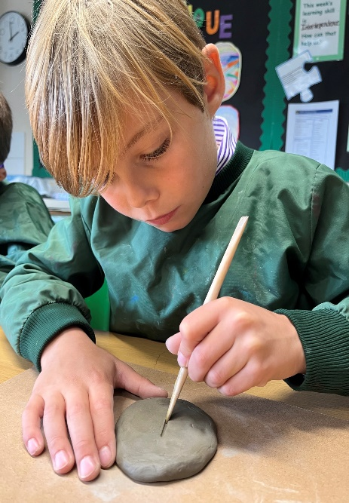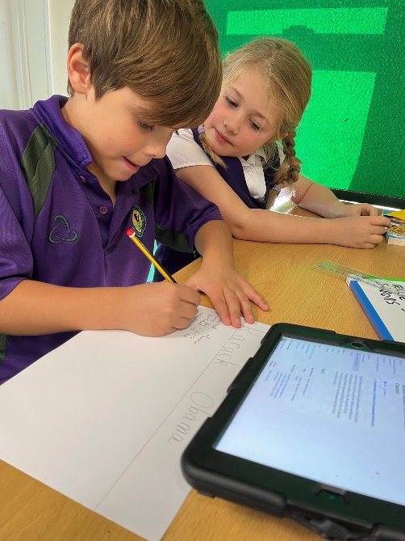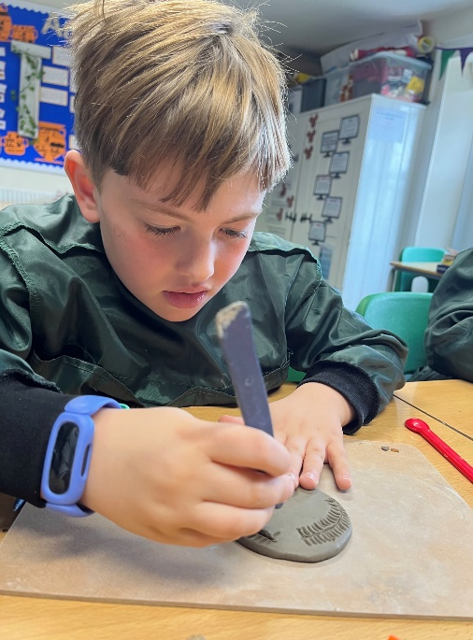

|  |
| --- |
| Black History Month is celebrated in October in the UK.  This month is to focus on how we can acknowledge and learn from the past to ensure a fairer future.  This month is a good starting point to celebrate the continued achievements and contributions of Black people to the UK and the world around us. It’s also a time for continued action to tackle racism and reclaim Black history. However, as educators and parents we must ensure that this education is represented and celebrated all year round.  Within school we promote inclusivity in our every day lives in a variety of ways. To name a few; classrooms promote diversity in different ways through books, visual timetables, and posters, fundamental British values, and through PSHE lessons we challenge stereotypes, discussing that the way that people look does not define them.    In Squirrels this week, the class was split into 4 teams and allocated a category: sports, history, TV/film or music, and were challenged to name as many role models in that category as possible. Afterwards, we discussed Black History Month and why it is celebrated. We looked at some role models together, such as Rosa Parks, Marcus Rashford, Martin Luther King, Mary Seacole and Dr Mae Jamison and shared who we had heard of. We thought about the face that there is a reason that we’ve heard of fewer black role models and that in the past, and all too often in current times too, black people often had/have fewer opportunities.  We watched some short informational videos on Rosa Parks and Martin Luther King, and it was humbling to see the shocked and disappointed reactions on the children’s faces when we discussed the act of segregation  and the unfairness people suffered.  Within our groups, we then researched different black role models and learned about their achievements and accomplishments.    Elsewhere, we have continued with our DT project, and made our clay medals, inspired by both the ancient and modern Olympics. The class worked well on their carving skills.    As we come to the end of a busy half term, I would like to say a big well done to the Squirrels. They have worked hard, and I hope they have a well-deserved rest over half term.  I would also like to take the opportunity to say huge thank you to Maria Keates, who will be off on maternity leave. You will be leaving the class with a ‘Mrs Keates’ shaped hole and I know the class will miss you hugely, but we wish you luck and can't wait to meet baby Keates!  We are looking forward to announcing our new teaching assistant when arrangements are confirmed.  **Stacey Watson** **, Year 4** |
| A person writing on a piece of paper  Description automatically generated with medium confidence  This week in Owls, we have been busy adding the finishing touches to our Harvest Play and warming up our singing voices ready for the Church Service on Friday. The children have also had the opportunity to share their thoughts on their experience of school and their personal learning journeys during the discussions for “My Voice”. It was wonderful to hear how enthusiastic the children feel about their learning and how supported they feel by the Springmead community.  We have also continued to explore newspaper recounts in English and have begun the planning process, ready to delve into our written pieces on Friday. We will also be finishing off our Maths unit on Addition and Subtraction this week, ready to move onto Multiplication and Division after the half term break.  Well done to all of Owls for a wonderful first term in Year 5, you have all settled in so well to Upper Key Stage 2 and it is great to see you all taking new responsibilities and routines in your stride and moving towards greater independence. I hope you all have a restful half- term and take time to reflect on your achievements from the past few weeks.    **Lydia Adams, Year 5** |

|  |
| --- |
| With the first half term coming to a close the Eagles are able to look back on a great first six weeks full of learning and fantastic experiences:  Becoming Ambassadors  Bikeability  MacMillan Coffee Morning  Poetry Competition  Bushcraft Sessions  Harvest Preparations  Fixtures  Showcase Auditions  School Party  Entrance test clubs  Such a lot has been squeezed into a short period of time, especially when you add in all of the classwork, learning about creation stories, the British Empire, William Morris, Internet safety, managing risks and danger, Charles Darwin and more. Of course, we must not forget the Maths and English work that forms the core of each day.  The Eagles are looking forward to their two-week break and will be recharging their batteries in preparation for another exciting and busy half-term to come!  **Nick Munckton, Year 6** |

**Out of School Achievements**

Do please share your child’s out of school news and successes with us so we can celebrate. Please email details to [mtaylor@springmead.com](mailto:mtaylor@springmead.com) and [scox@springmead.com](mailto:scox@springmead.com)

Have a fabulous holiday!

Sally Cox

**Headteacher**

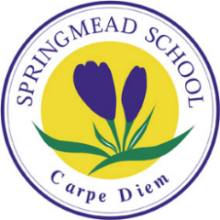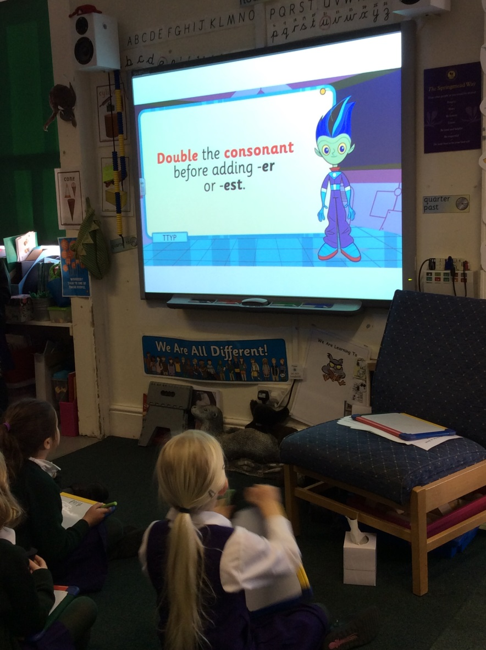

***‘Springmead School is committed to safeguarding and promoting the welfare of children and expects all staff and volunteers to share this legal and moral responsibility’.***

Springmead School

Castle Corner, Beckington, Somerset BA11 6TA

01373 831555 [info@springmead.com](mailto:info@springmead.com) [www.springmead.com](http://www.springmead.com)

Directors: M. Taylor & J. Beardsley

Taypenny Schools Ltd. Registered office:

4 Beaufort Way, Bath, BA1 6QB

Registered in England No. 3090822